Definición Máquinas de Turing

Máquina para reconocer palíndromos de a, b y c:

M = ({q0, q1, q2, q3, q4, q5, q6, q7, q8, q9}, {a, b, c}, {a, b, c, x}, δ, q0, B, q0)

Tabla de transiciones:

|  |  |  |  |  |  |
| --- | --- | --- | --- | --- | --- |
|  | a | b | c | B | x |
| *q0 | (q1, x/R) | (q2, x/R) | (q3, x/R) | - | - |
| q1 | (q1, a/R) | (q1, b/R) | (q1, c/R) | (q4, B/L) | (q4, x/L) |
| q2 | (q2, a/R) | (q2, b/R) | (q2, c/R) | (q5, B/L) | (q5, x/L) |
| q3 | (q3, a/R) | (q3, b/R) | (q3, c/R) | (q6, B/L) | (q6, x/L) |
| q4 | (q8, x/L) | - | - | - | - |
| q5 | (q9, x/L) | - | - | - | - |
| q6 | (q7, x/L) | - | - | - | - |
| q7 | (q7, a/L) | (q7, b/L) | (q7, c/L) | - | (q0, x/R) |
| q8 | (q8, a/L) | (q8, b/L) | (q8, c/L) | - | (q0, x/R) |
| q9 | (q9, a/L) | (q9, b/L) | (q9, c/L) | - | (q0, x/R) |

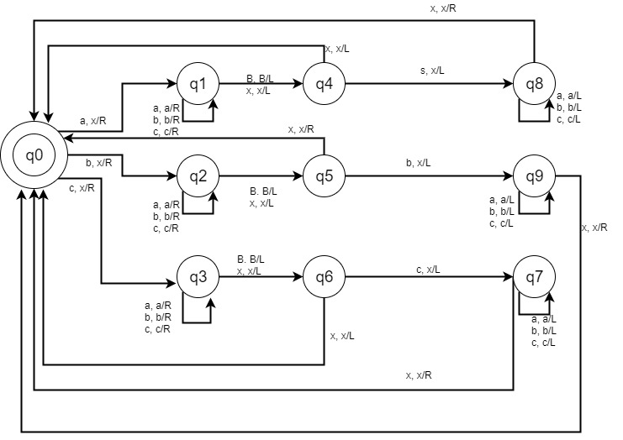

Máquina para copiar palabras a, b, c:

M = ({q0, q1, q2, q3, q4, q5, q6, q7, q8, q9, q10, q11, q12, q13, q14, q15, q16, q17}, {a, b, c}, {a, b, c, x, y, B}, δ, q0, B, q17)

|  |  |  |  |  |  |  |
| --- | --- | --- | --- | --- | --- | --- |
|  | a | b | c | x | y | B |
| q0 | (q1, a/R) | (q1, b/R) | (q1, c/R) | - | - | - |
| q1 | (q1, a/R) | (q1, b/R) | (q1, c/R) | - | - | (q2, y/L) |
| q2 | (q2, a/L) | (q2, b/L) | (q2, c/L) | - | - | (q3, B/R) |
| q3 | (q4, a/R) | (q4, b/R) | (q4, c/R) | - | - | - |
| q4 | (q5, x/R) | (q7, x/R) | (q9, x/R) | - | (q11, y/L) | - |
| q5 | (q5, a/R) | (q5, b/R) | (q5, c/R) | - | (q5, y/R) | (q6, a/L) |
| q6 | (q6, a/L) | (q6, b/L) | (q6, c/L) | (q4, a/R) | (q6, r/L) | - |
| q7 | (q7, a/R) | (q7, b/R) | (q7, c/R) | - | (q7, y/R) | (q8, b/L) |
| q8 | (q8, a/L) | (q8, b/L) | (q8, c/L) | (q4, b/R) | (q8, y/L) | - |
| q9 | (q9, a/R) | (q9, b/R) | (q9, c/R) | - | (q9, y/R) | (q10, c/L) |
| q10 | (q10, a/L) | (q10, b/L) | (q10, c/L) | (q4, c/R) | (q10, y, L) | - |
| q11 | (q11, a/L) | (q11, b/L) | (q11, c/L) | - | - | (q12, B/R) |
| q12 | (q13, a/R) | (q14, b/R) | (q15, c/R) | - | - | - |
| q13 | (q13, a/R) | (q13, b/R) | (q13, c/R) | - | (q16, a/R) | - |
| q14 | (q14, a/R) | (q14, b/R) | (q14, c/R) | - | (q16, b/R) | - |
| q15 | (q15, a/R) | (q15, b/R) | (q15, c/R) | - | (q16, c/R) | - |
| q16 | (q16, a/R) | (q16, b/R) | (q16, c/R) | - | - | (q17, B/L) |
| *q17 | - | - | - | - | - | - |

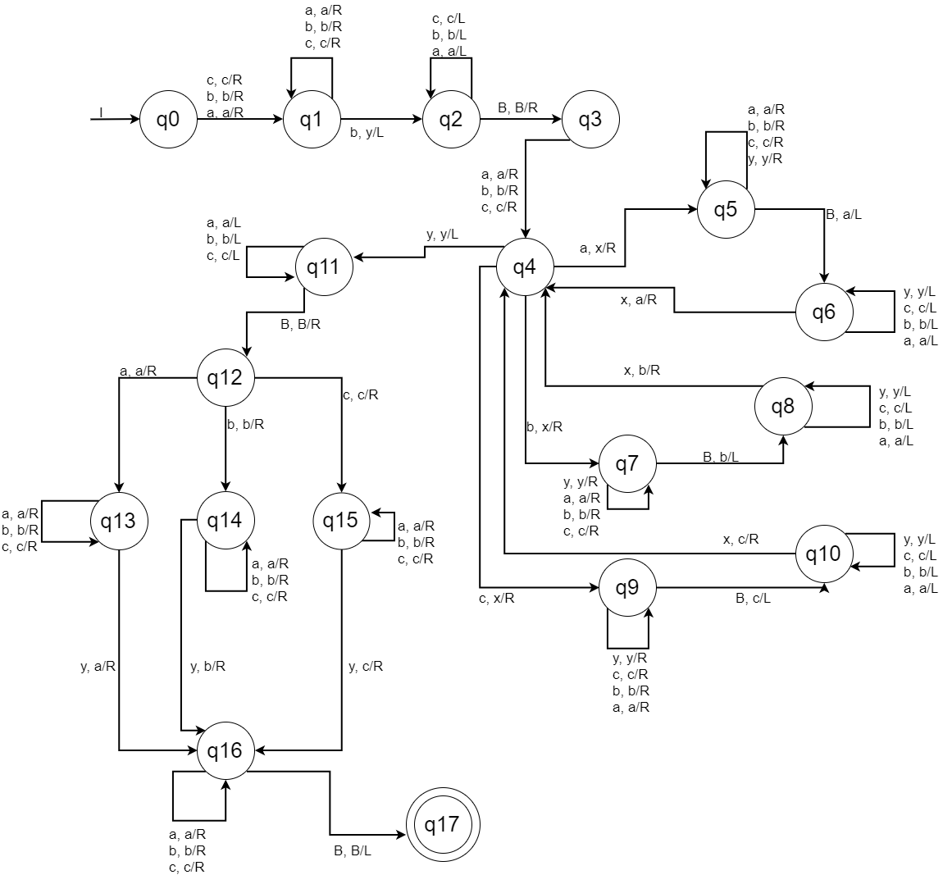

Máquina para multiplicación en código unario:

M = ({q0, q1, q2, q3, q4, q5, q6, q7, q8}, {1, *, =}, {1, *, =, x, y, B}, δ, q0, B, {q8})

|  |  |  |  |  |  |  |
| --- | --- | --- | --- | --- | --- | --- |
|  | 1 | * | = | x | y | B |
| q0 | (q1, x/R) | - | - | - | - | - |
| q1 | (q1, 1/R) | (q2, */R) | - | - | - | - |
| q2 | (q3, y/R) | - | - | - | - | - |
| q3 | (q3, 1/R) | - | (q3, =/R) | - | - | (q4, 1/L) |
| q4 | (q4, 1/L) | - | (q4, =/L) | - | (q5, 1/R) | - |
| q5 | (q3, y/R) | - | (q6, =/L) | - | - | - |
| q6 | (q6, 1/L) | (q6, */L) | - | (q7, x/R) | - | - |
| q7 | (q1, x/R) | (q8, */L) | - | - | - | - |
| *q8 | - | - | - | - | - | - |

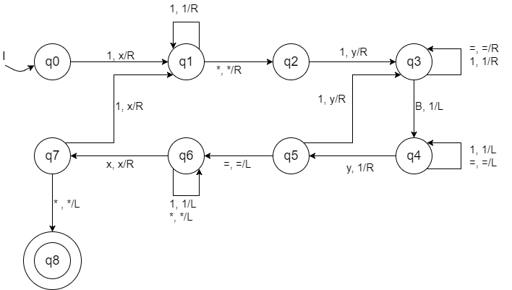

Suma en Código Unario:

M = ({q0, q1, q2, q3, q4, q5}, {1, +, =}, {1, +, =, x, B}, δ, q0, B, q5)

|  |  |  |  |  |  |
| --- | --- | --- | --- | --- | --- |
|  | 1 | + | = | x | B |
| q0 | (q1, x/R) | - | - | - | - |
| q1 | (q1, 1/R) | (q1, +/R) | (q1, =/R) | - | (q2, 1/L) |
| q2 | (q2, 1/L) | (q2, +/L) | (q4, =/L) | (q3, x/R) | - |
| q3 | (q1, x/R) | (q0, +/R) | - | - | - |
| q4 | (q2, 1/L) | - | - | (q5, x/R) | - |
| *q5 | - | - | - | - | - |

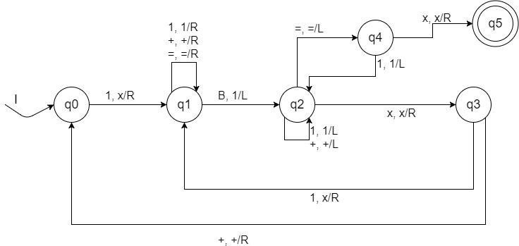

Resta en Código Unario

M = ({q0, q1, q2, q3, q4, q5, q6, q7, q8, q9}, {1, -, =}, {1, -, =, B, x}, δ, q0, B, {q9})

|  |  |  |  |  |  |
| --- | --- | --- | --- | --- | --- |
|  | 1 | - | = | B | x |
| q0 | (q1, x/R) | - | - | - | - |
| q1 | (q1, 1/R) | (q1, -/R) | (q1, =/R) | (q2, 1/L) | - |
| q2 | (q2, 1/L) | (q2, -/L) | (q2, =/L) | - | (q3, x/R) |
| q3 | (q1, x/R) | (q4, -/R) | - | - | - |
| q4 | (q5, x/R) | - | - | - | - |
| q5 | (q5, 1/R) | - | (q5, =/R) | (q6, B/L) | - |
| q6 | (q7, B/L) | - | - | - | - |
| q7 | (q7, 1/L) | - | (q7, =/L) | - | (q8, x/R) |
| q8 | (q5, x/R) | - | (q9, =/L) | - | - |
| *q9 | - | - | - | - | - |

